AI Diagnostic & Observability Agent
Architecture Description
This document describes a modular, security-first architecture for an AI-driven diagnostic agent that correlates telemetry, source code, and operational context to identify root causes and suggest fixes.
The design emphasizes:
- Hybrid-cloud and on-prem flexibility
- Strong privacy controls
- Extensible connector-based integrations
- Scalable multi-agent orchestration

1) High-Level Architecture
The system follows a Multi-Agent Orchestrator pattern. A central supervisor delegates work to specialized agents, each focused on one investigation domain (telemetry, code, or documentation context).
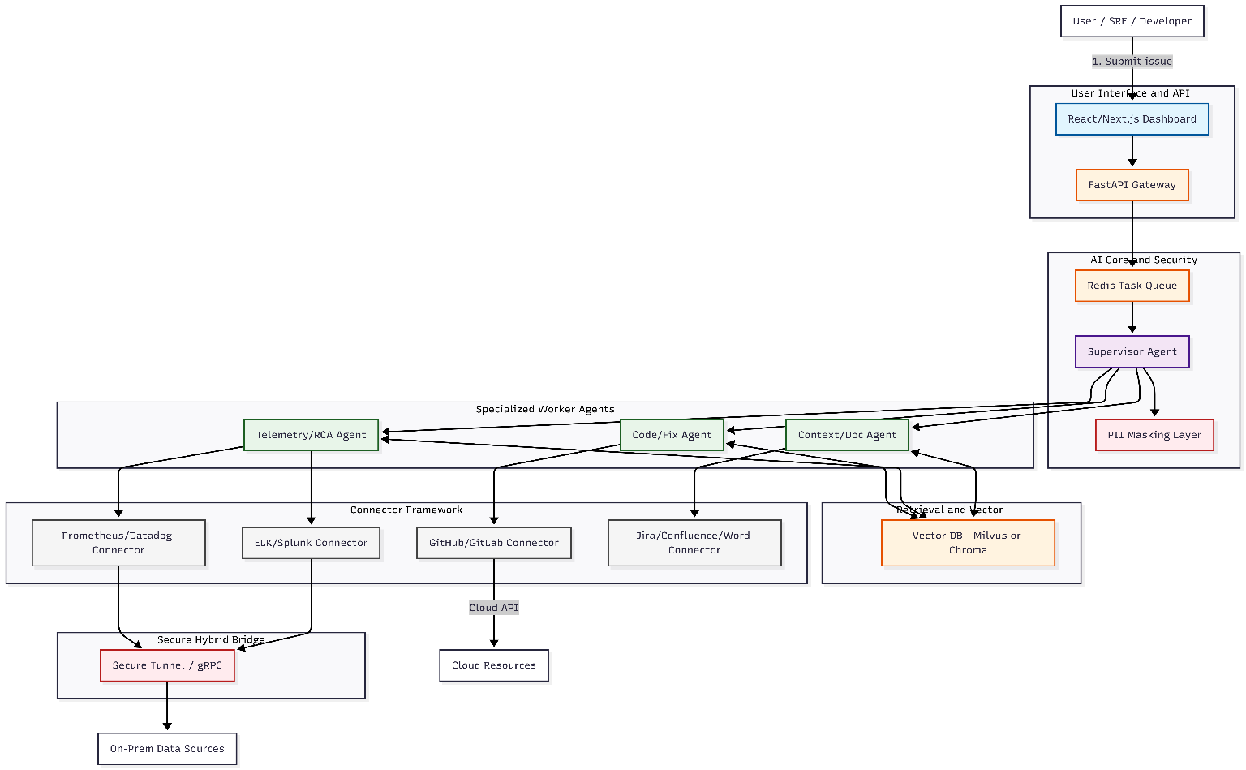

2) Component Breakdown
A. Supervisor Orchestrator
The supervisor is the decision engine. Instead of a single long prompt, it uses a state-machine approach (for example, LangGraph) to decide:
- Which agent to invoke next
- What data to gather first
- When to parallelize vs. sequence tasks
Example flow
- Input: "Login page is slow in East US."
- Step 1: Ask Telemetry Agent to check latency and error trends.
- Step 2: Ask Code Agent to inspect recent auth-service changes.
- Step 3: Ask Context Agent for related Jira/release notes.
B. Specialized Worker Agents
Telemetry/RCA Agent
- Queries metrics and logs (PromQL, KQL, vendor APIs)
- Detects spikes, saturation, 5xx bursts, cold starts, and regional anomalies
Code/Fix Agent
- Uses RAG to retrieve relevant code regions and historical context
- Correlates regressions with recent commits and blame metadata
- Proposes candidate fixes based on observed failure modes
Context/Doc Agent
- Extracts intent from tickets, runbooks, RFCs, and release notes
- Identifies expected behavior changes that explain anomalies
C. Retrieval and Memory Layer
Vector storage (Milvus/Chroma) enables semantic retrieval over:
- Source code and commit history
- Incident documentation
- Operational playbooks and prior diagnostics
This improves grounding and reduces hallucinations in generated analysis.
D. Connector Framework
Each external integration is implemented behind a standard connector interface. This allows plug-and-play replacement:
- ELK -> Splunk
- GitHub -> GitLab
- Prometheus -> Datadog
without changing core orchestrator logic.
E. Hybrid Data Bridge
For private/on-prem environments, the architecture uses an outbound secure tunnel (reverse-proxy or gRPC channel):
- On-prem systems initiate the connection
- Cloud orchestrator reuses the established channel
- No inbound firewall ports are required

3) Security, Privacy, and Compliance
- PII masking: scrub emails, IPs, tokens, and sensitive payloads before LLM processing.
- Least-privilege access: connectors operate with scoped credentials and audit trails.
- Boundary-aware deployment: support cloud, private VPC, or fully on-prem execution.
- Data residency controls: keep sensitive telemetry/docs within approved environments.

4) Production Readiness and Scaling
- Async investigations: task queues (Redis/Celery-style workers) decouple UI from long-running diagnostics.
- Horizontal scaling: independently scale worker pools by workload type (telemetry-heavy vs code-heavy).
- Real-time UX: stream investigation progress to UI via WebSockets/server push.
- Fault tolerance: retry transient connector failures and checkpoint orchestration state.

5) Operational Workflow
- Issue intake: user submits an incident description, alert, or stack trace.
- Decomposition: supervisor generates a sequence/graph of investigation steps.
- Parallel retrieval: agents gather telemetry, code history, and contextual docs.
- Correlation: results are fused to identify likely root cause and confidence.
- Output: UI presents a diagnostic report and suggested remediation actions.

6) Deployment Models
- SaaS: fully managed stack in public cloud.
- Private Cloud: orchestrator/UI in customer VPC; connectors access private systems.
- On-Prem: complete deployment inside customer environment, including local LLM options.

7) Example Investigation Scenario
- Symptom: "Login latency spike in East US."
- Telemetry Agent finds increased p95 and 5xx in auth endpoints.
- Code Agent identifies a recent cache-related change in auth service.
- Context Agent finds a ticket indicating caching was intentionally disabled for release testing.
- Supervisor concludes likely cause, explains trade-off, and recommends safe rollback or config guardrails.

8) Recommended Next Enhancements
- Confidence scoring across multi-agent evidence
- Human-in-the-loop approval for automated fix suggestions
- Incident memory for recurring issue detection
- Policy-driven redaction profiles per data source

